Task 3 Documentation

In this task I decided to 3D model Iron Man but as it is quite a complex project I broke it down to different sections and finally chose to create a bust of the outer shell.

To create this model I used these blueprints.

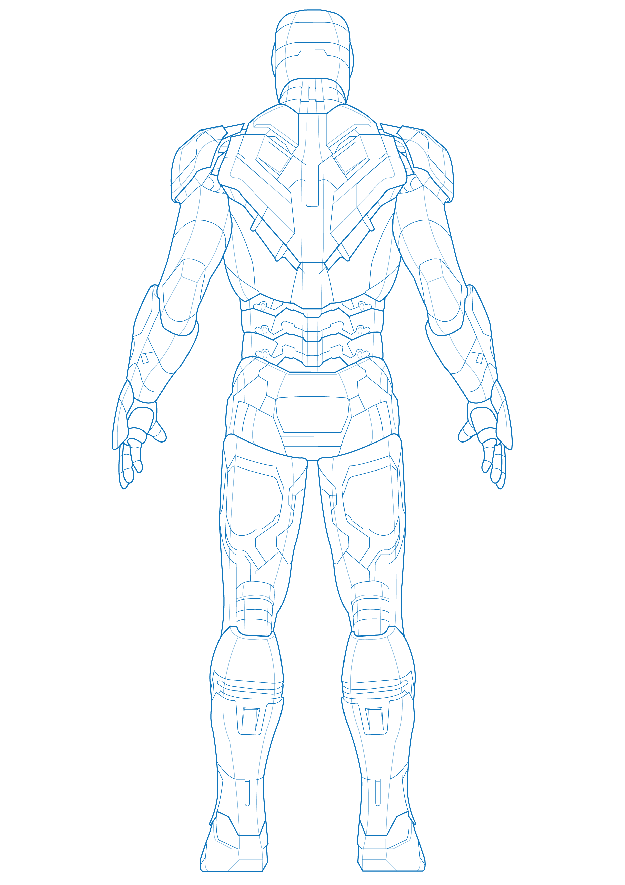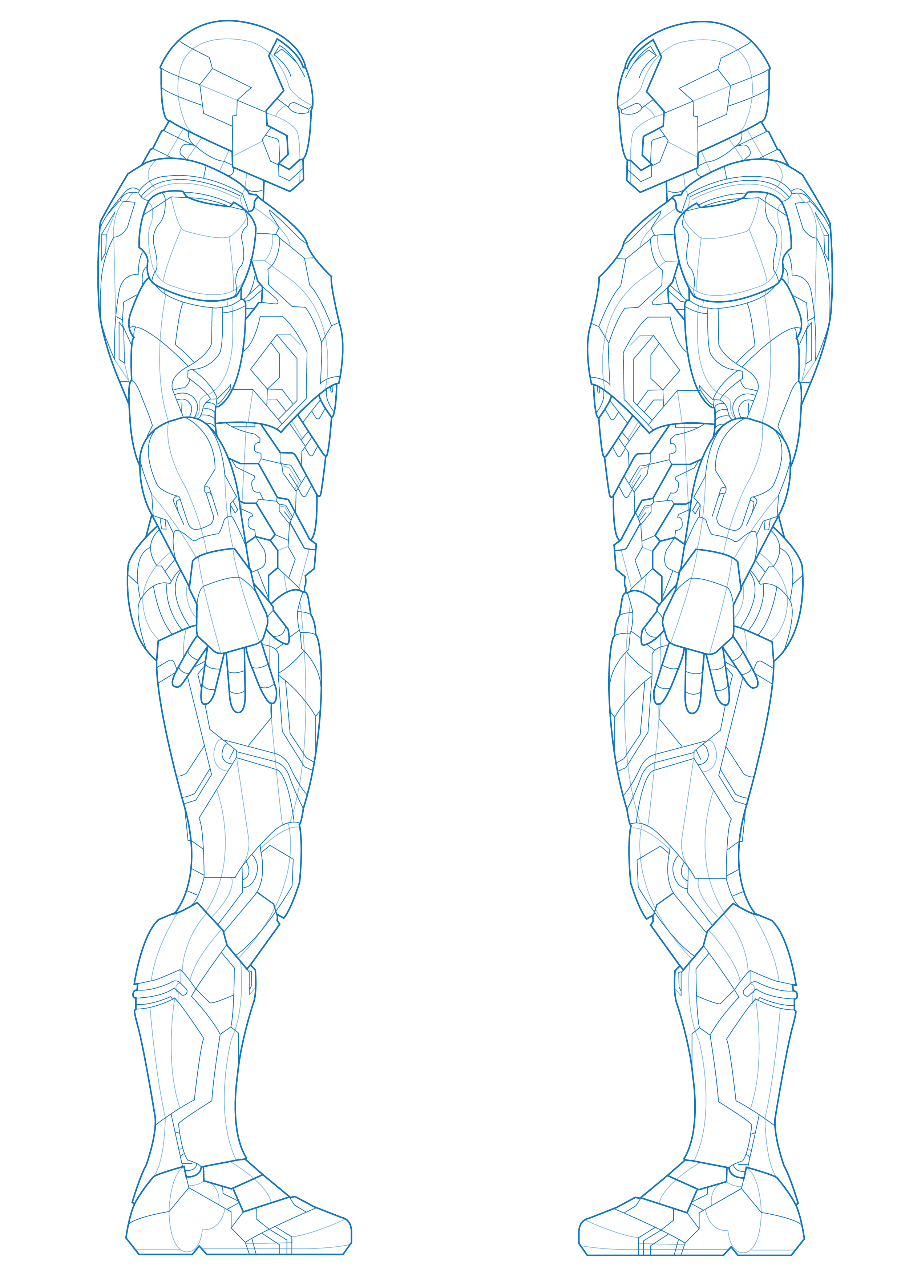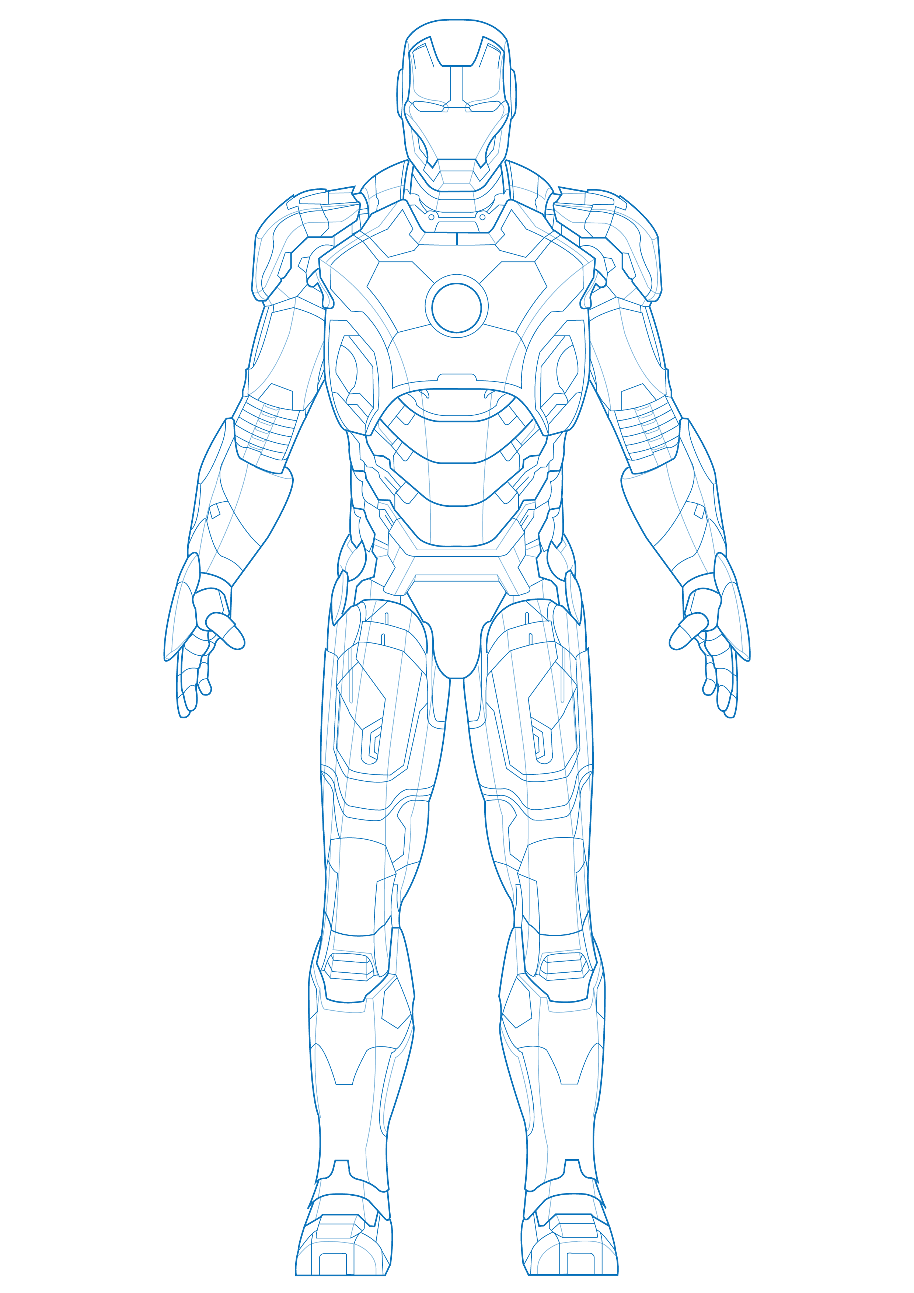

To create the model i used various techniques the main one was using the create polygon tool to sculpt the different pieces of the model according to the blueprints which I set up in the different views making sure to keep the same scale.

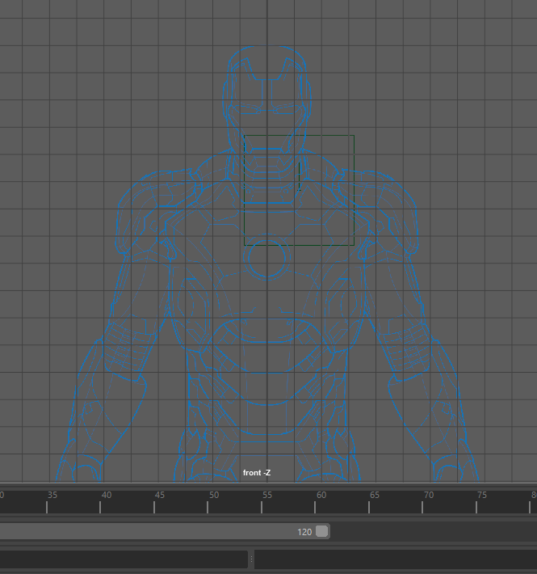

Create polygon tool.

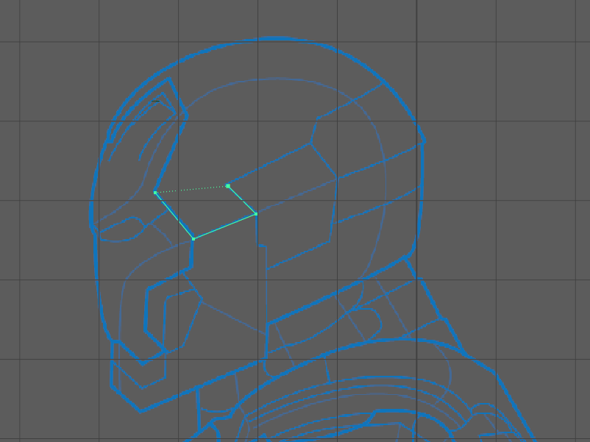

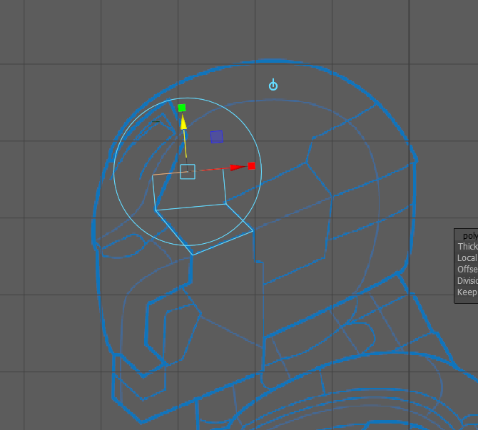To create the shape while following the blueprint I used the extrude tool to extrude the edges to fully trace the blueprint.

Once I had one of the shape done then I used the mirror tool to create the other half with perfect symmetry making it easier to create the rest of the shape.

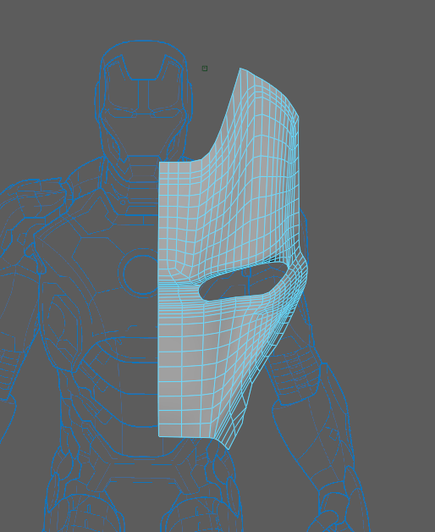

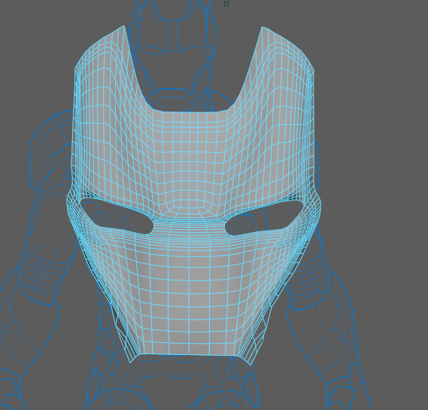

To create the rest of the head of iron man i split it into different sections:

The mask

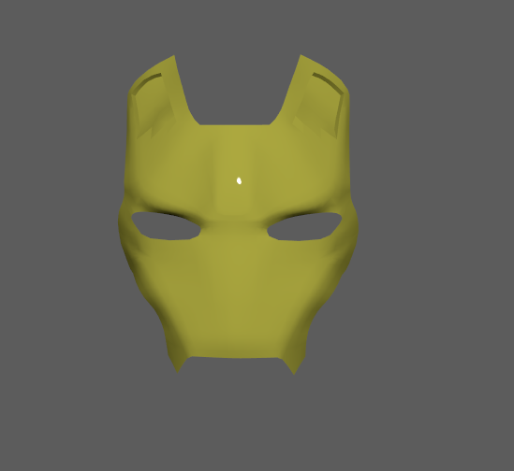

The back of the helmet

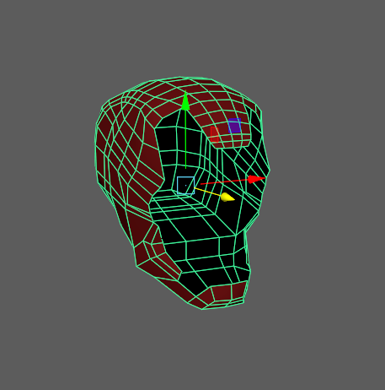

The chin strap

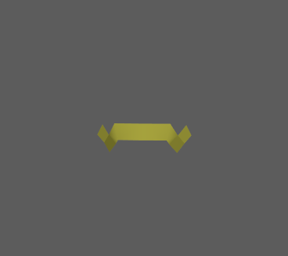

The neck

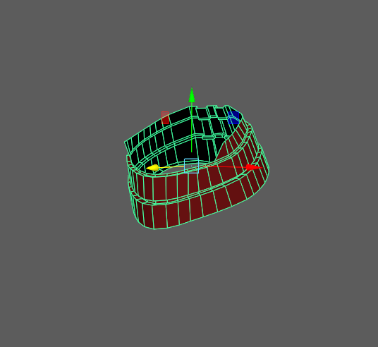

To make sure that each half of the model fit properly i used the merge vertices tool to make sure that there weren’t any stray verts.

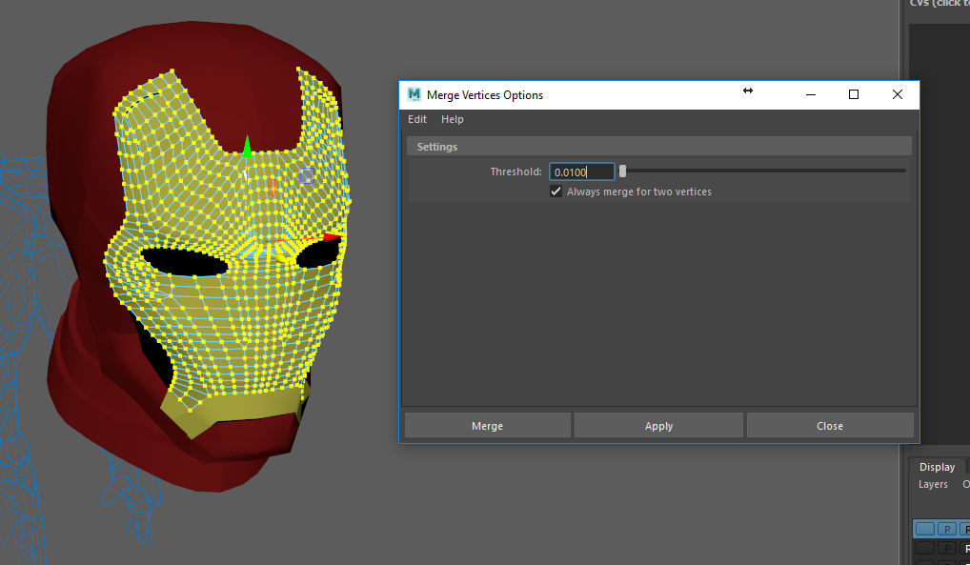

To make sure not to confuse the different components I gave them temporary colours to give it a more pleasing look while I work.

When it came to the chest part of the model I decided to use the same technique I used for the head but this time after creating all the different pieces I joined all of them together to make it flow a lot better as the curves of the front piece are a lot more prominent

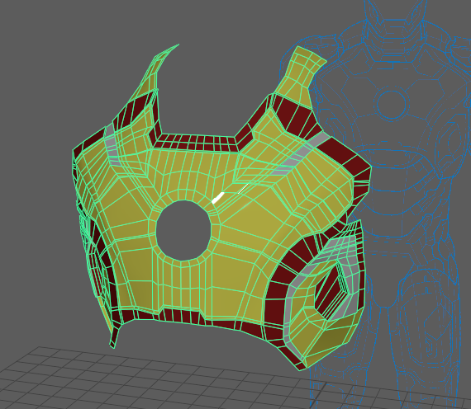

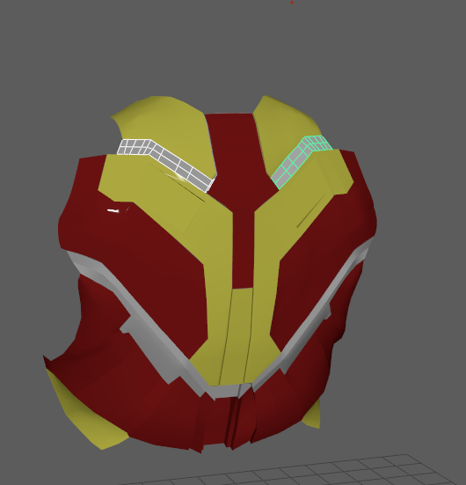The back of the model while using the same techniques i split it into several pieces as it required a bit more defined edges.

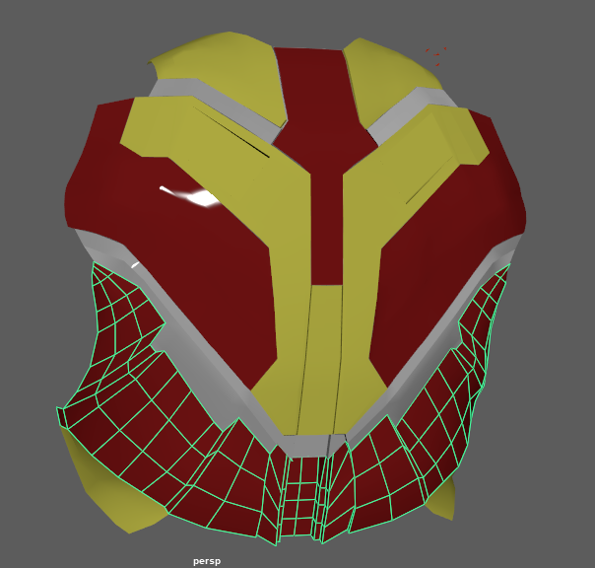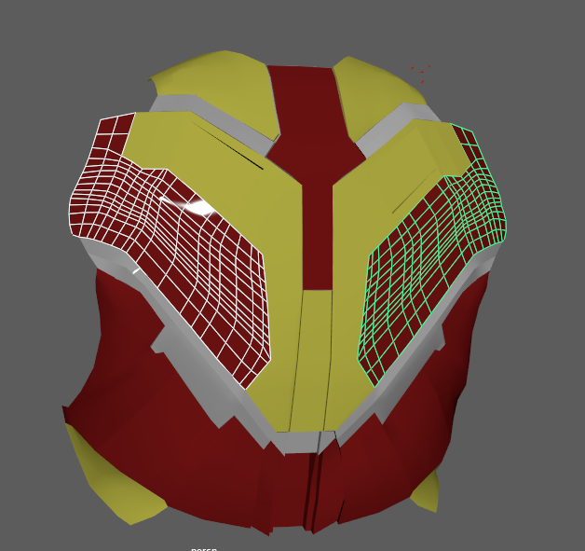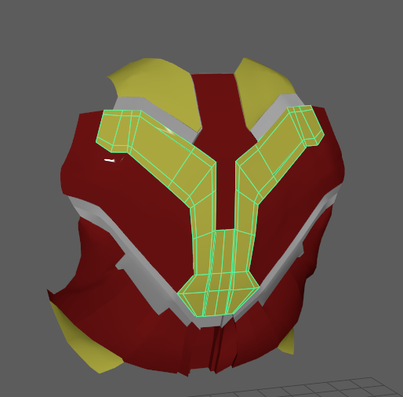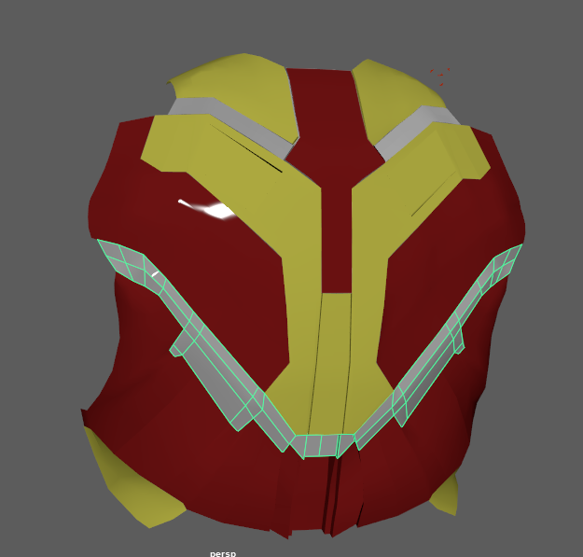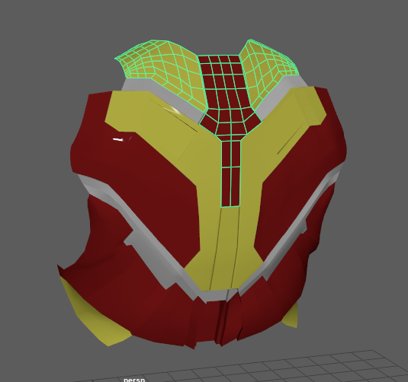

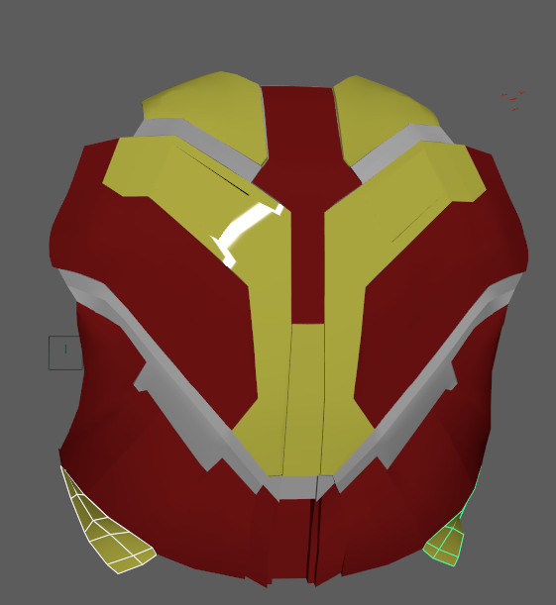

After I created the whole of the model I created the UV map for each object using the stitching tool and the sew tool to create the UV maps for all the objects. Like the one below for the chest.

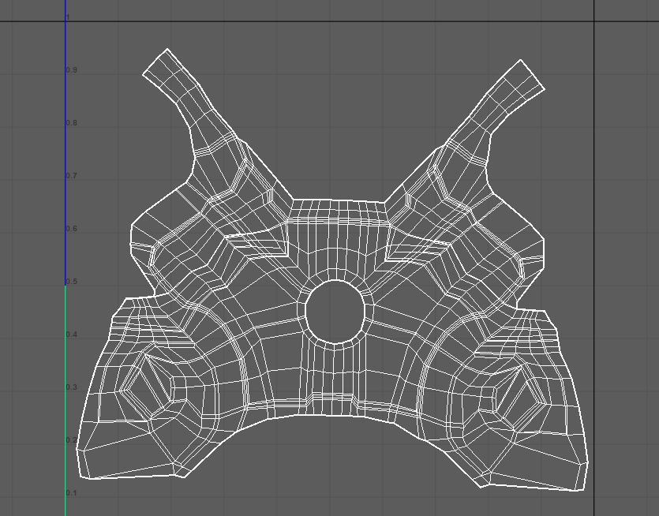

After I created all the Uvs I used photoshop to give the Uvs the proper colours for Iron Man using this colour palette.

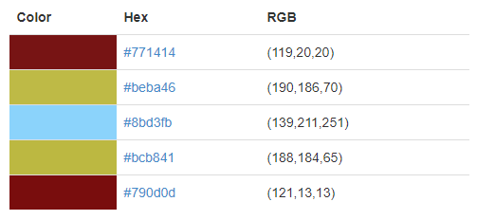

In photoshop I used the polygon laso tool to select the ares and give them a certain colour, I used this technique mostly on the chest section of the model.

